Δελτίο της Ελληνικής Γεωλογικής Εταιρίας τομ. XXXVI, 2004  Πρακτικά 10^{ου} Διεθνούς Συνεδρίου, Θεσ/νίκη Απρίλιος 2004 | Bulletin of the Geological Society of Greece vol. XXXVI, 2004  Proceedings of the 10th International Congress, Thessaloniki, April 2004
ABSTRACT CODE: RS1_133

Comparative geochemical study of plutonites from the northern pelagonian zone
Koroneos A.¹, Gerouki F.², Soldatos T.¹, and Christofides G.¹
¹ Department of Mineralogy-Petrology-Economic Geology, School of Geolofy, Aristotle University of Thessaloniki, 546 21, Thessaloniki, koroneos@geo.auth.gr, soldatos@geo.auth.gr, christof@geo.auth.gr
² I.G.M.E., Mesogion Str. 70, 115 27, Athens

ABSTRACT
Plutonic rocks of upper paleozoic age from the Northern Pelagonian Zone which intrude the crystalline basement are studied and compared. According to their spatial relationship they are divided into two groups: the plutonites of Baba (BAB), Varnous (VAR), Ag. Germanos (AGG), Oxya (OXY), Prasino (PRA), Kastoria (KAS) and Ardassa (ARD) consist the northern group (BO), and the plutonites of Kastania (KST), Katafygio (KAT), Olympias (OLY), Verdikoussa (VER) and Deskati (DSK) consist the southern group (NO). The plutonites of the BO group are mainly metalumunous and have similar geochemical characteristics. Exception are OXY (peraluminous) and ARD (peralkaline). In the NO group the plutonites are metaluminous as well. KST is similar to KAT and OLY to VER, but the former two differ from the latter two. DSK (peraluminuous) is markedly different compared to the rest. Geotectonically the plutonites of the Northern Pelagonian Zone seem to relate to a volcanic arc environment.

INTRODUCTION (main 1st order heading)
In this study published and unpublished data are used in order to compare the plutonites of the Northern Pelagonian Zone and define the geochemical similarities and differences, the geotectonic environment and the composition of the parental magma.

GEOLOGY
The Pelagonian Zone is a tectonic cover emplaced during Eocene over the carbonate unit of Olympus. It consists of a) a polymetamorphic crystalline basement of palaeozoic age, b) a metaclastic sequence of late palaeozoic – early triassic age, c) a recrystallized carbonate cover of triassic-jurassic age and d) a carbonate cover of cretaceous age (Papadopoulos 1983, Rollinson 1984, Spyropoulos 1985, Kilias & Moundrakis 1988, Moundrakis & Kilias 1988, Papazachos & Chatzidimitriou 1989a, Papazachos & Chatzidimitriou 1989b, Sfeikos & Frisch 1990, Asteriadis et al. 1993, Pearce et al. 1996, Pe-Piper et al. 1997a, Pe-Piper et al. 1997b, Bogdanov & Saric 2000). Intermediate to acid plutonites intrude the above described basement (Fig. 1).

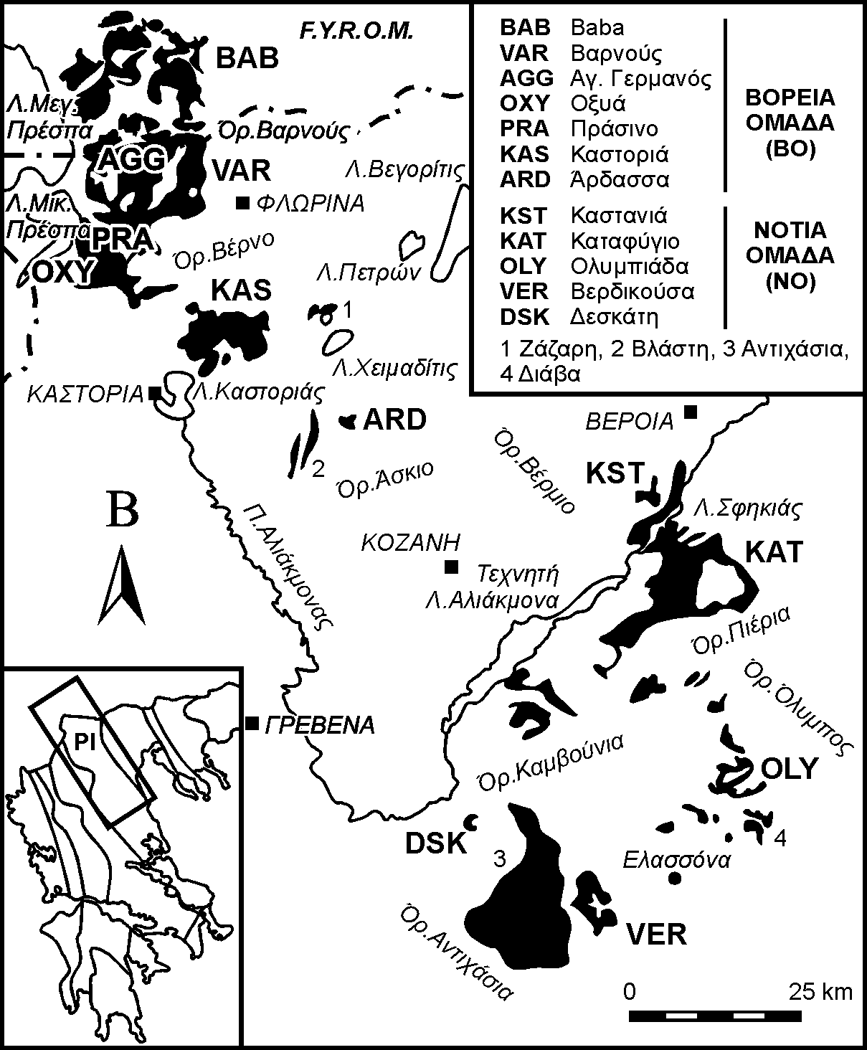
Figure 1. The plutonites of the Northern Pelagonian Zone (Pl).

The age of the plutonites, according to K-Ar, Rb-Sr and U-Pb radiochronological data ranges between 290-310 MA.

DESCRIPTION OF THE PLUTONITES

Petrography (Indicative 2nd heading)

Classification (Indicative 3rd heading)
In figure 2 Yarwood & Aftalion (1976), Davi & Migiros (1980), Koroneos (1991), Pe-Piper et al. (1997b) και Koroneos et al. (2000) distinguish the plutonites on the basis of silica content.

Mineralogical composition (Indicative 3rd heading)
The mineral constituents are quartz, K-feldspar, plagioclase, amphibole, biotite, muscovite, and accessories (magnetite, allanite, titanite etc.)

Geochemistry
For the geochemical study of the plutonic rocks of the Northern Pelagonian Zone 332 chemical analyses have been used (Tab. 1).

Major elements
In table 1 it is shown that SiO₂ ranges from 50.55 to 76.90 wt.% and Κ₂Ο from 2.98 to 5.13 wt.%.

Trace elements
In the rocks of the BO group Rb is rathjer stable relative to silica content and ranges from 50 to 250 ppm. The rocks of BO group are enriched in Sr, Ba and Ni (Fig. 3).

Table 1. Selected major (wt.%) and trace-element (ppm) chemical analyses of the plutonic rocks of the Northern Pelagonian Zone.

Sample | VAR | OXY | KST | KAS | OLY | VER | DSK
SiO₂ | 50.55 | 69.52 | 70.15 | 70.77 | 68.27 | 68.98 | 76.90
TiO₂ | 1.27 | 0.42 | 0.36 | 0.32 | 0.58 | 0.39 | 0.26
Al₂O₃ | 16.55 | 13.60 | 14.13 | 15.17 | 14.49 | 15.49 | 11.93
Fe₂O_{3t} | 8.73 | 2.56 | 2.45 | 2.44 | 3.36 | 2.76 | 2.47
MnO | 0.16 | 0.08 | 0.06 | 0.06 | 0.08 | 0.06 | 0.02
MgO | 6.52 | 1.56 | 1.02 | 0.76 | 2.44 | 1.53 | 0.23
CaO | 6.99 | 2.24 | 2.24 | 2.48 | 0.92 | 2.30 | 0.34
Na₂O | 3.87 | 3.71 | 3.87 | 3.46 | 4.07 | 3.93 | 2.72
K₂O | 3.66 | 4.84 | 4.01 | 3.65 | 3.57 | 2.98 | 5.13
P₂O₅ | 0.86 | N.A.* | <D.L.* | 0.13 | 0.16 | 0.13 | 0.03
LOI | 1.60 | 1.15 | 1.22 | 1.22 | 1.60 | 1.11 | 0.38
Rb | 166 | 190 | 132 | 140 | 125 | 94 | 150
Sr | 970 | 423 | 564 | 328 | 69 | 391 | 46
Ba | 1244 | 856 | 1022 | 620 | 505 | 796 | 235
* N.A.: Not analyzed, <D.L.: Below detection limit

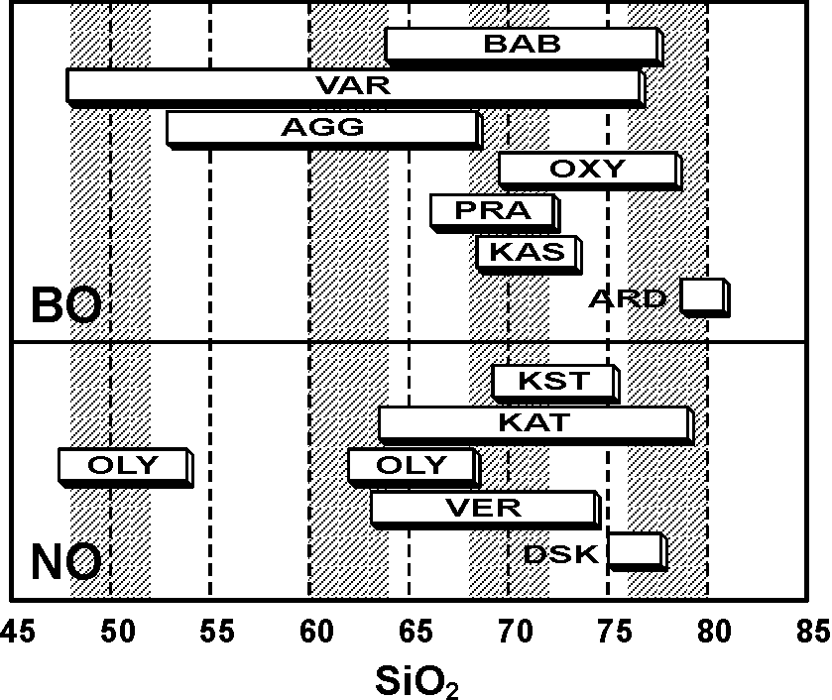 | 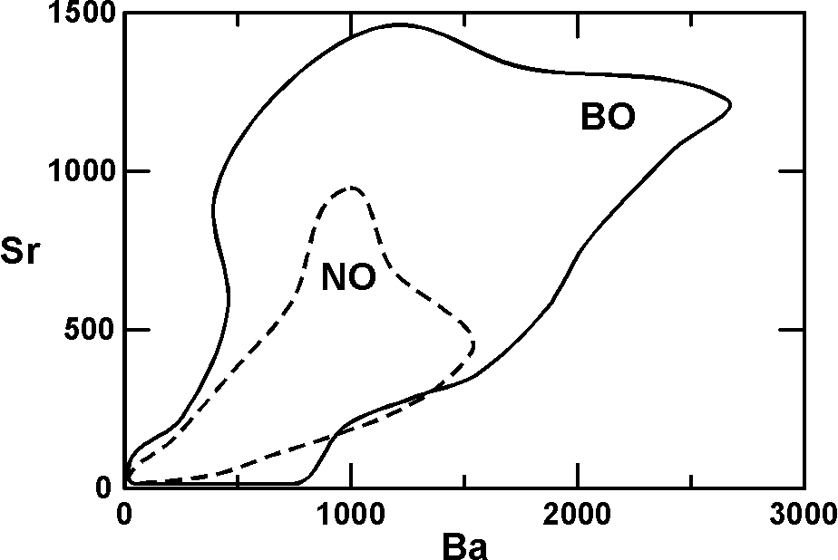
Figure 2. Range of SiO₂ (wt.%) in the plutonic rocks of the Northern Pelagonian Zone. | Figure 3. Sr - Ba variation diagram (ppm) the plutonic rocks of the Northern Pelagonian Zone.

Geotectonic environment
Based on major elements the plutonites of the Northern Pelagonian Zone plot on the field of volcanic arc granites.

conclusions
The geochemical comparison between the plutonites of the Northern Pelagonian Zone shows that they have a lot of similarities as well as differences.
- Common characteristic is the high content of alkalies and the negative Nb anomaly.
- The geotectonic environment is a subduction zone of a continental plate under an oceanic one.
AGKNOWLEDGEMENTS
The authors would like to thank the Greek Science Foundation (IKY) for its financial support through project 111/2004.
REFERENCES
Asteriadis A., Gerouki F. & Matheopoulos D. 1993. Plutonites of the Northern Pelagonian Zone. Unpublished report, I.G.M.E., 50pp (in Greek).
Bogdanov R. & Saric K. 2000. Plutonic rocks in Bulgaria. Geol. Balc., 20, 256-268 (in Russian with English abstract)
Davi E.N.. & Migiros G.P. 1980. Granitic intrusions in the Eastern Thessalia. Bull. Geol. Soc. Greece, 15, 168-183 (in Greek with English abstract).
Kilias A. & Moundrakis D. 1988. Tectonics, metamorphism and magmatism of Northern Pelagonian Zone. Bull. Geol. Soc. Greece, 23/1, 29-46 (in Greek with English abstract).
Koroneos A. 1991. Mineralogy, petrology and geochemistry of the Eastern Varnountas plutonite (NW Macedonia). Ph.D. thesis, Univeristy of Thessaloniki, 450pp (in Greek with English abstract).
Koroneos A., Soldatos T., Christofides G. & Eleftheriadis G. 2000. Genesis of the Eastern Varnountas plutonite (NW Macedonia). Bull. Geol. Soc. Greece, 30/1, 193-204 (in Greek with English abstract).
Moundrakis D. & Kilias Α. 1988. The geological structure of the Northern Pelagonian Zone and the geotectonic evolution of the Internal Hellenides. Mineral Wealth, 15, 20-32 (in Greek).
Papadopoulos Z. 1983. The geological structure of the Northern Pelagonian Zone. Dissertation, Univeristy of Thessaloniki, 289pp (in Greek).
Papazachos K.B. & Chatzidimitriou P. 1989a. Genesis of the Western Varnountas plutonite (NW Macedonia). 5th Panhellenic Geographical Congress, Athens, 94-100 (in Greek).
Papazachos K.B. & Chatzidimitriou P. 1989b. Introduction to Geophysics. University Studio, Thessaloniki, 320pp (in Greek).
Pearce J.A., Harris N.B.W. & Tindle A.C. 1996. Trace element discrimination diagrams for the tectonic interpretation of granitic rocks. J. Petrol., 25,4, 956-983.
Pe-Piper G., Doutsos T. & Mijara A. 1997a. Petrology and regional significance of the Hercynian granitoid rocks of the Olympiada area, Northern Thessaly, Greece. Chem. Erde, 53, 21-36.
Pe-Piper G., Doutsos T. & Poronkay C. 1997b. Geochemical characteristics of collision-zone magmatism. In: Collision Tectonics, Coward, M.P. & Ries, A.C. eds, Geol. Soc. Spec. Publ., Blackwell Scientific Publlications, Oxford, London, Edinburgh, Boston, 19, 67-81.
Rollinson H. 1984. Using geochemical data: evaluation, presentation interpretation. Longman Group UK Ltd., Oxford, 352p.
Sfeikos & Frisch 1990, A chemical approximation to the modal QAPF classification of the igneous rocks. N. Jb. Min. Abh., 136, 169-206.
Spyropoylos N. 1985. The geological structure of the Northern Pelagonian Zone in moyntain Askio. Ph.D. thesis, Univeristy of Thessaloniki, 251pp (in Greek with English abstract).
Yarwood G.A. & Aftalion 1976. Field relations and U-Pb geochronology of a granite from the Pelagonian zone of the Hellenides (High Pieria, Greece). Bull. Soc. Geol. France, 18(2), 259-264.
Yarwood G.A. 1978. The structure, metamorphism and geochronology of the High Pieria Mountains, N. Greece. Ph. D. Thesis (unpubl.), University Edinburgh, 100p.

When references in the text are within parentheses:
- References are in lower-case letters except the first letter of each author, which is capital.
eg. (Papadopoulos 1983, Rollinson 1984, Kilias & Moundrakis 1988,...)
- References are in chronological and not in alphabetical order.
eg. (Papadopoulos 1983, Rollinson 1984, Kilias & Moundrakis 1988,...)
- References within the same year are in alphabetical order.
eg. (Kilias & Moundrakis 1988, Moundrakis & Kilias 1988,...)
- References are separated with commas.
eg. (Papadopoulos 1983, Rollinson 1984, Kilias & Moundrakis 1988,...)
- In the same reference author and year are separated with comma.
eg. (Papadopoulos 1983, Pearce et al. 1996,...)
- In references with two authors, the authors are separated with «&».
eg. (Kilias & Moundrakis 1988, Sfeikos & Frisch 1990,...)
- References with more than two authors, the first author is followed by «et al.».
eg. (Asteriadis et al. 1993, Pearce et al. 1996,...)
- If the same authors appear in more than one reference, the year is followed by «a. b...».
eg. (Papazachos & Chatzidimitriou 1989a, Papazachos & Chatzidimitriou 1989b, Pe-Piper et al. 1997a, Pe-Piper et al. 1997b...)

Example:
(Papadopoulos 1983, Rollinson 1984, Kilias & Moundrakis 1988, Moundrakis & Kilias 1988, Papazachos & Chatzidimitriou 1989a, Papazachos & Chatzidimitriou 1989b, Sfeikos & Frisch 1990, Asteriadis et al. 1993, Pearce et al. 1996, Pe-Piper et al. 1997a, Pe-Piper et al. 1997b, Bogdanov & Saric 2000).
When references in the text are outside parentheses:
- The same rules mentioned above hold with the year placed in parentheses.

Παράδειγμα:
Papadopoulos (1983), Rollinson (1984), Kilias & Moundrakis (1988), Moundrakis & Kilias (1988), Papazachos & Chatzidimitriou (1989a), Papazachos & Chatzidimitriou (1989b), Sfeikos & Frisch (1990), Asteriadis et al. (1993), Pearce et al. (1996), Pe-Piper et al. (1997a), Pe-Piper et al. (1997b), Bogdanov & Saric (2000)
Figures mentioned in the text:
- When a figure mentioned in the text: figure 2.
eg. In figure 2 it is shown...
- When a figure mentioned in the text is in parentheses: (Fig. 1).
eg. plutonites intrude the above described basement (Fig. 1).
Photographs mentioned in the text:
- Photographs are mentioned as figures.
eg. In the photo (Fig. 3) it is shown... or
eg. In the photo of figure 3 it is shown
Tables mentioned in the text:
- When a table is mentioned in the text: table 2.
eg. In table 2 it is shown...
- When a table mentioned in the text is in parentheses: (Tab. 1).
eg. Twelve analyses have been made (Tab. 1).
REFERENCES at the end of the paper
- References are in alphabetical order.
- References other than in English are translated to English and at the end the original language is mentioned.
eg. Koroneos A., Soldatos T., Christofides G. & Eleftheriadis G. (2000). Genesis of the Eastern Varnountas plutonite (NW Macedonia). Bull. Geol. Soc. Greece, 30/1, 193-204 (in Greek with English abstract).

